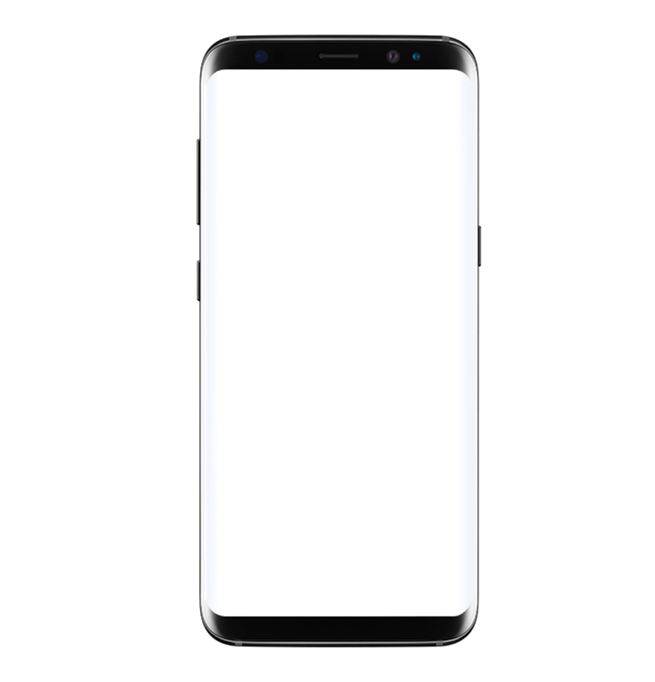

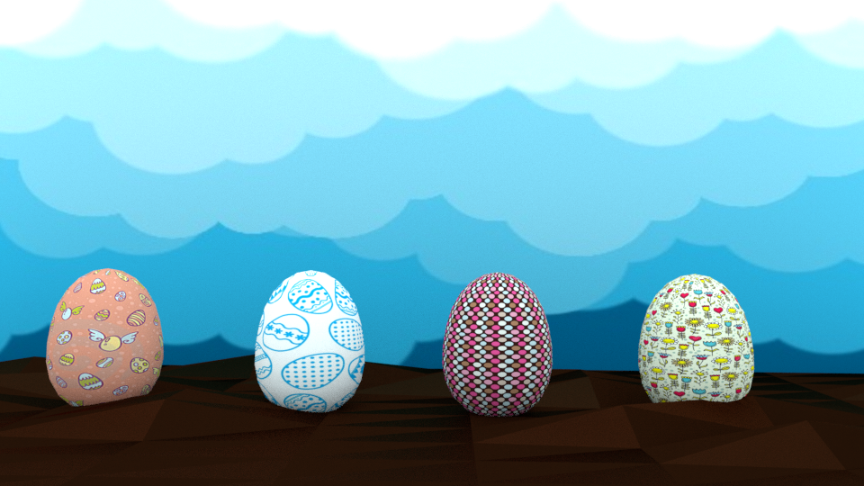

**CHOOSE YOUR EGG &**

**START THE ADVENTURE**